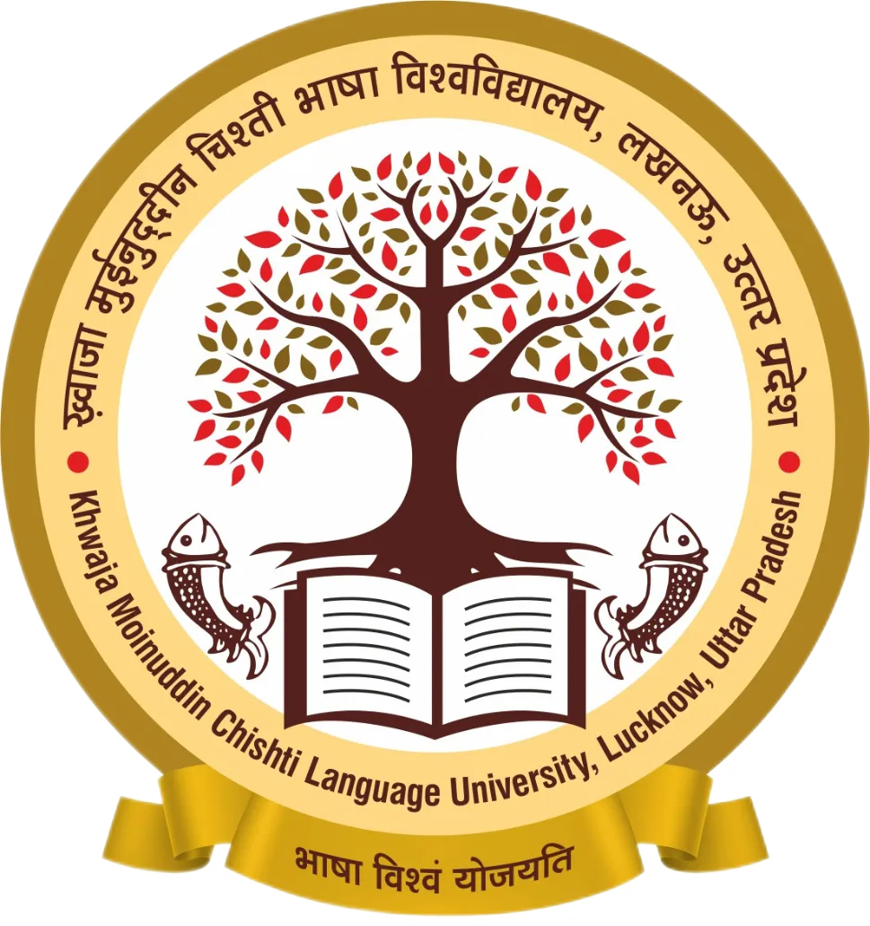
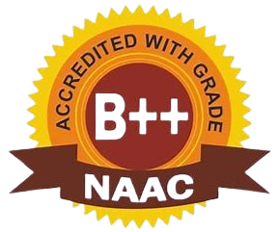
Faculty Profile on University Website
www.kmclu.ac.in

Name |  |  | Dr. Ajay Kumar Yadav |  |  |  |  | 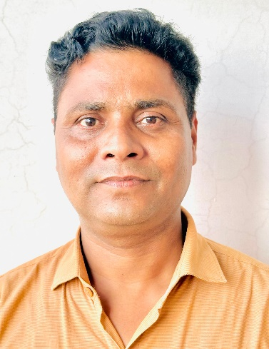
Designation |  |  | Assistant Professor
Department |  |  | Chemistry
Contact Details
Email |  |  | ajayyadav@kmclu.ac.in, ajayy473@gmail.com
Mobile No. |  |  | +91-9005079623
LinkedIn Profile Link |  |  | https://www.linkedin.com/in/dr-ajay-kumar-yadav-528557101/
Twitter Profile Link |  |  | https://x.com/bbau_yadavajay
Educational Qualification
Exam | Board/University |  |  |  |  | Subject |  |  | Passing Year
B.Sc. | University of Lucknow, Lucknow |  |  |  |  | Chemistry, Zoology, Botany |  |  | 2006
M.Sc. | CSJM University, Kanpur |  |  |  |  | Chemistry |  |  | 2008
M.Phil. | CSJM University, Kanpur |  |  |  |  | Chemistry |  |  | 2011
NET (AIR 10th) | CSIR-UGC, New Delhi |  |  |  |  | Chemical Sciences |  |  | 2019
Ph.D. | Babasaheb Bhimrao Ambedkar University (A Central University), Lucknow |  |  |  |  | Applied Chemistry |  |  | 2022
Details of Service
Employer’s Name and City |  | Designation |  |  | Type | Date (from) | Date (up to) |  | Total Experience
Ram Janki Mahavidyalaya Asai, Bairi, Sawai, Kanpur Dehat |  | Assistant Professor |  |  | Contractual | 05 June 2012 | 31 October 2017 |  | 05 years, 04 months
Khwaja Moinuddin Chishti Language University, Lucknow |  | Assistant Professor |  |  | Temporary | 11 November 2022 | Continue
Academic Details
Teaching Area/Specialization |  |  |  | - Chemistry, 2. Organic Chemistry
Teaching Experience |  |  |  | Teaching Experience (In Years): 09 Years  - Assistant Professor, Department of Chemistry, Ram Janki Mahavidyalaya Asai, Bairi, Sawai, Kanpur Dehat (Chhatrapati Sahu Ji Maharaj University, Kanpur), (05 June 2012 to 31 October 2017).  - Assistant Professor, Department of Chemistry, Khwaja Moinuddin Chishti Language University, Lucknow. (11 November 2022 to continue).
Research Area |  |  |  | Synthetic Organic Chemistry:  - Development of novel and highly efficient sustainable methodologies in Organic Chemistry.  - C-N bond formation.  - N-H/N-Alkyl aziridination.  - Design and sustainable development of aminating reagents.
Orchid ID |  |  |  | https://orcid.org/0000-0002-1461-4893
Vidwan ID |  |  |  | 705605
Google Scholar Profile Etc. |  |  |  | https://scholar.google.com/citations?user=paCsxcMAAAAJ&hl=en

Research Details
No. of Research Publications | 09
Books | Book Chapters: 02
No. of P.hD./M.Phil. Awarded under Supervision | Nill
Projects and Their Details | Nill
No. Conferences/Seminars/Workshops Participated | 13
Honours/Awards
- Prof. S.M.L. Gupta Memorial Award for the best oral presentation
Administrative Services to the University
Community Service/Social Service/Other Contributions
Any Special Information
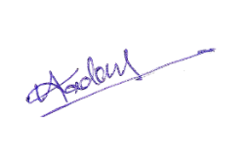
Signature of Faculty Member

